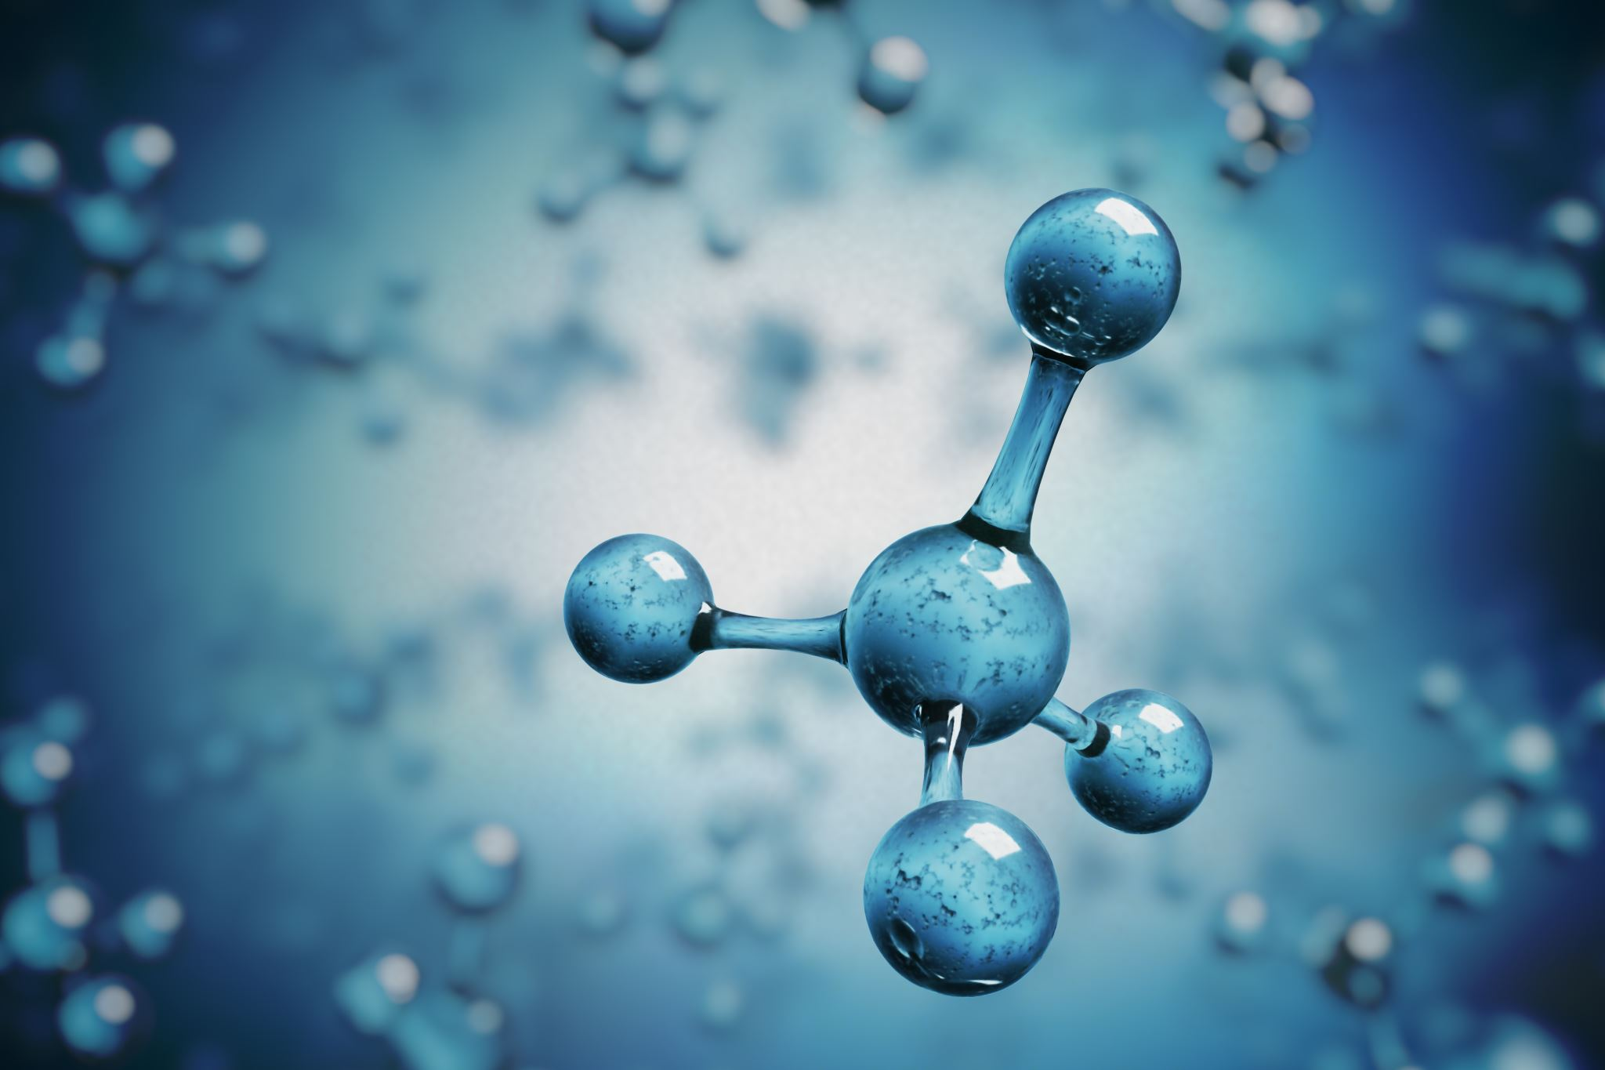  C  For more information, Contact :  Dr Naomi Melvin @ nmelvin@nfch.org  or  Sharon Steelfox,  Lab Manager @ Ssteelfox@nfch.org |  | Medical Technologist needed for molecular and main hospital lab:  AMT certified and Florida Licensure is required. Training can be provided for molecular lab  Northwest Hospital is located at 1360 Brickyard Road, Chipley, FL 32428 in the Panhandle, 40 miles from the world Most Beautiful Beaches of Panama City.  Phone: Hospital phone is 850-638-1610

MOLECULAR MEDICAL TECHNOLOGIST

